SOP – MS Ops – Impact DNS entry modification / new entry update

NOTE:- for any production related. Please refrain making any changes without Infra MS Ops knowledge and without valid SALAM Ops Team approval
Step 2:- connect to the 172.20.2.91 host (primary DNS) via the jump server 172.20.2.93 as opc user
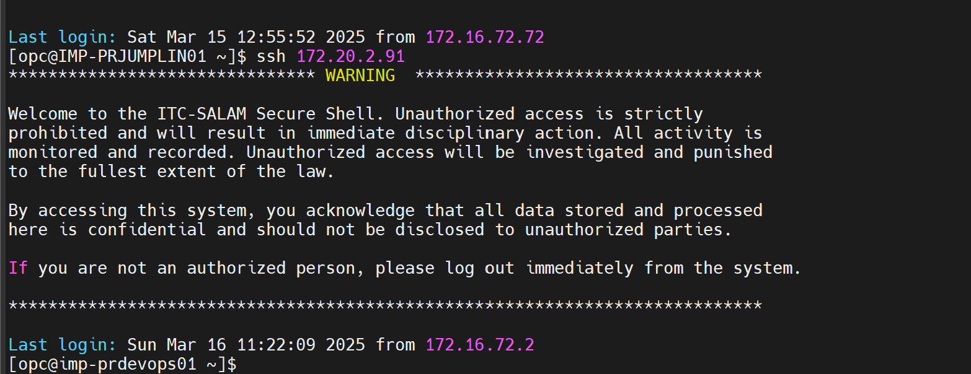
Step 3:- switch to root, sudo -i
Step 4:- take a backup of the existing forward config file as below
cp -rp /var/named/forward.itc.local /var/named/forward.itc.local.bkp.yyyymmdd
step 5:- if the request is to modify please follow the below steps,

- Vi /var/named/forward.itc.local
- Edit the existing serial number on the file to next successive one, irrespective of number of changes being made
- Select the entry to modify and make necessary update
- Please ensure to follow the same format as below with regards to the annotation.
- Restart the named service using systemctl restart named
- Validate the services before restart using systemctl status named
- Please request the team to validate post this change is done.
Step 6:- if the request is to make a new entry on DNS. Please follow the below steps,

- Vi /var/named/forward.itc.local
- Edit the existing serial number on the file to next successive one, irrespective of number of changes being made
- Go to the last line, press a space and make entry in last
- Please ensure to follow the same format as below with regards to the annotation.
- Restart the named service using systemctl restart named
- Validate the services before restart using systemctl status named
- Please request the team to validate post this change is done.

